MapleSyrup
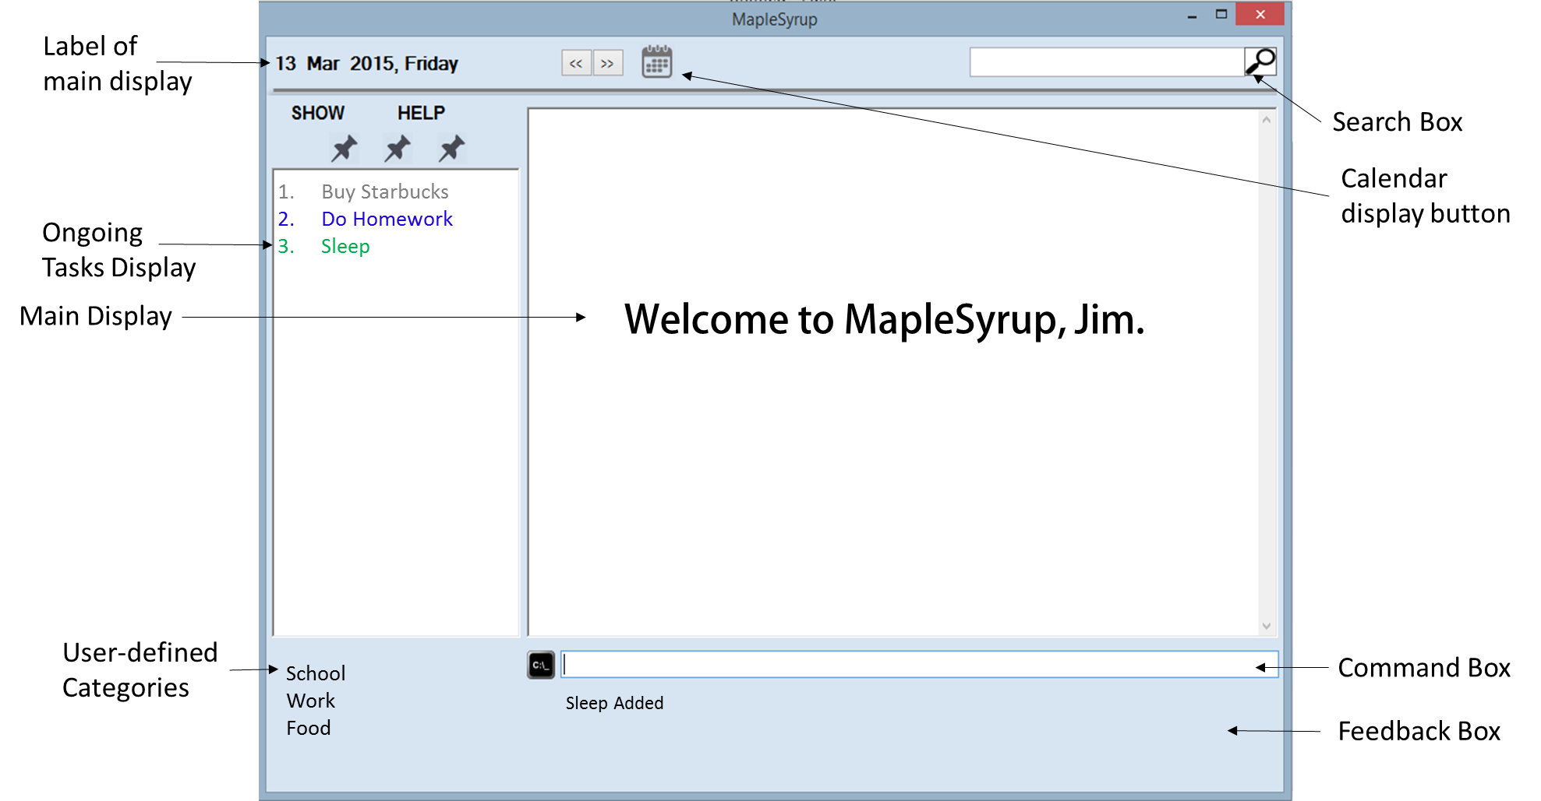
Supervisor: Lim Yu De Extra feature: GoodGUI
  Ong Wei Jee  Team Lead  Code Quality |   George Lam Changwei  Github Expert  Documentation |   Ter Yong Kang  GUI Designer  Deliverables and Deadlines |   Che Jian Yong Joshua  Integration  Scheduling and tracking

User guide

Introduction
Welcome to MapleSyrup, your go to application to keep track of tasks and events. An event in MapleSyrup consists of several details: the name, date, time, additional remarks, and tags. In this guide we will walk through the process of adding, deleting, editing and displaying events; starting by adding an event for today, 10 February. The event details are as follows: CS2103 exam, 11am-2pm.
Getting Started
- Double click MapleSyrup on your desktop.
- The program will be opened together with a welcome message
- The default display will show your tasks and events for today. On-going tasks will be permanently displayed.

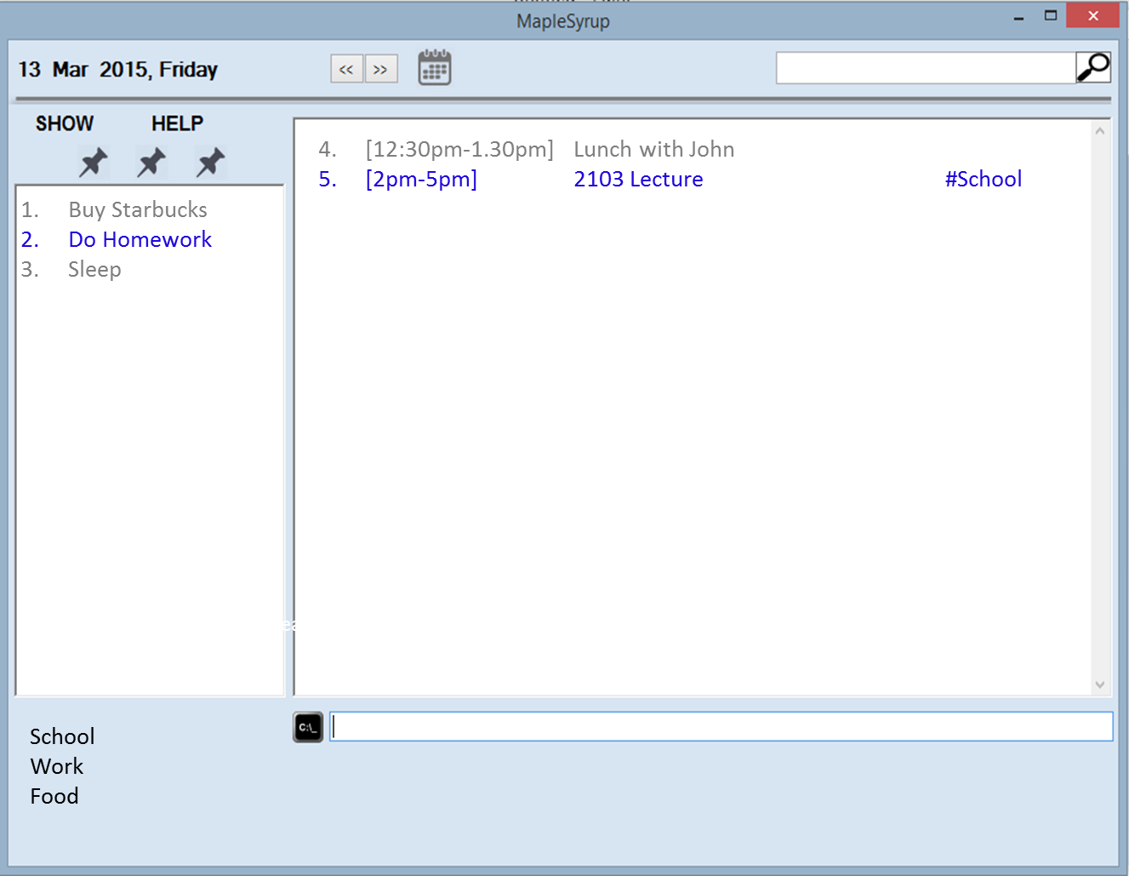

Functions
ADDING AN EVENT
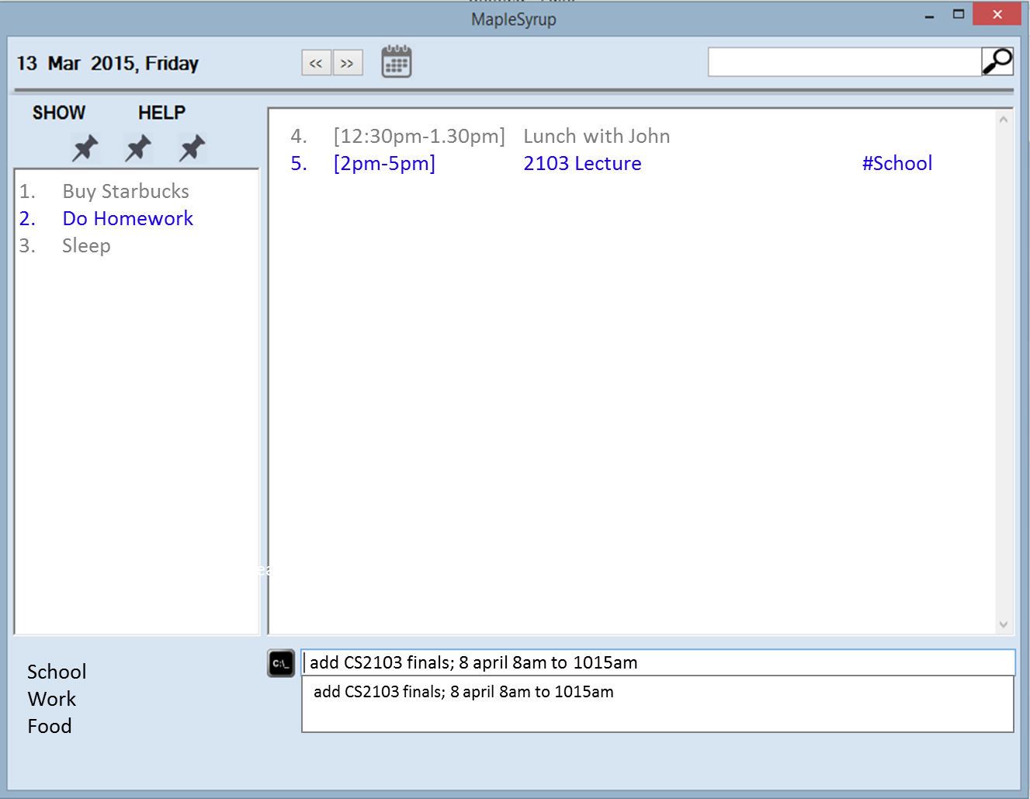
- For one-day events, type in command box “add [event name] @[date] [start time]-[end time]” (e.g. add CS2103 exam @10 feb 11am-2pm). Feedback box will display an acknowledgement “[Name of event] added.” Suggestion Box will appear to show you the correct format of input
- There are a total of 9 different ways to add an event: (Refer to joshua’s doc to include them)
- The display will show the event details (at the day of event page). Newly added event will be in green.
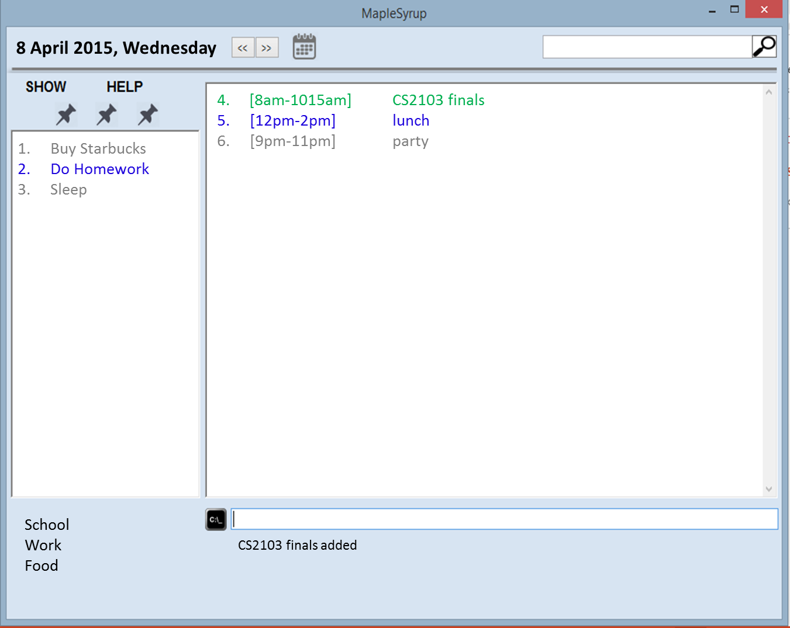

- If the new event clashes with an existing event, both clashed events (old and new) will be shown in red

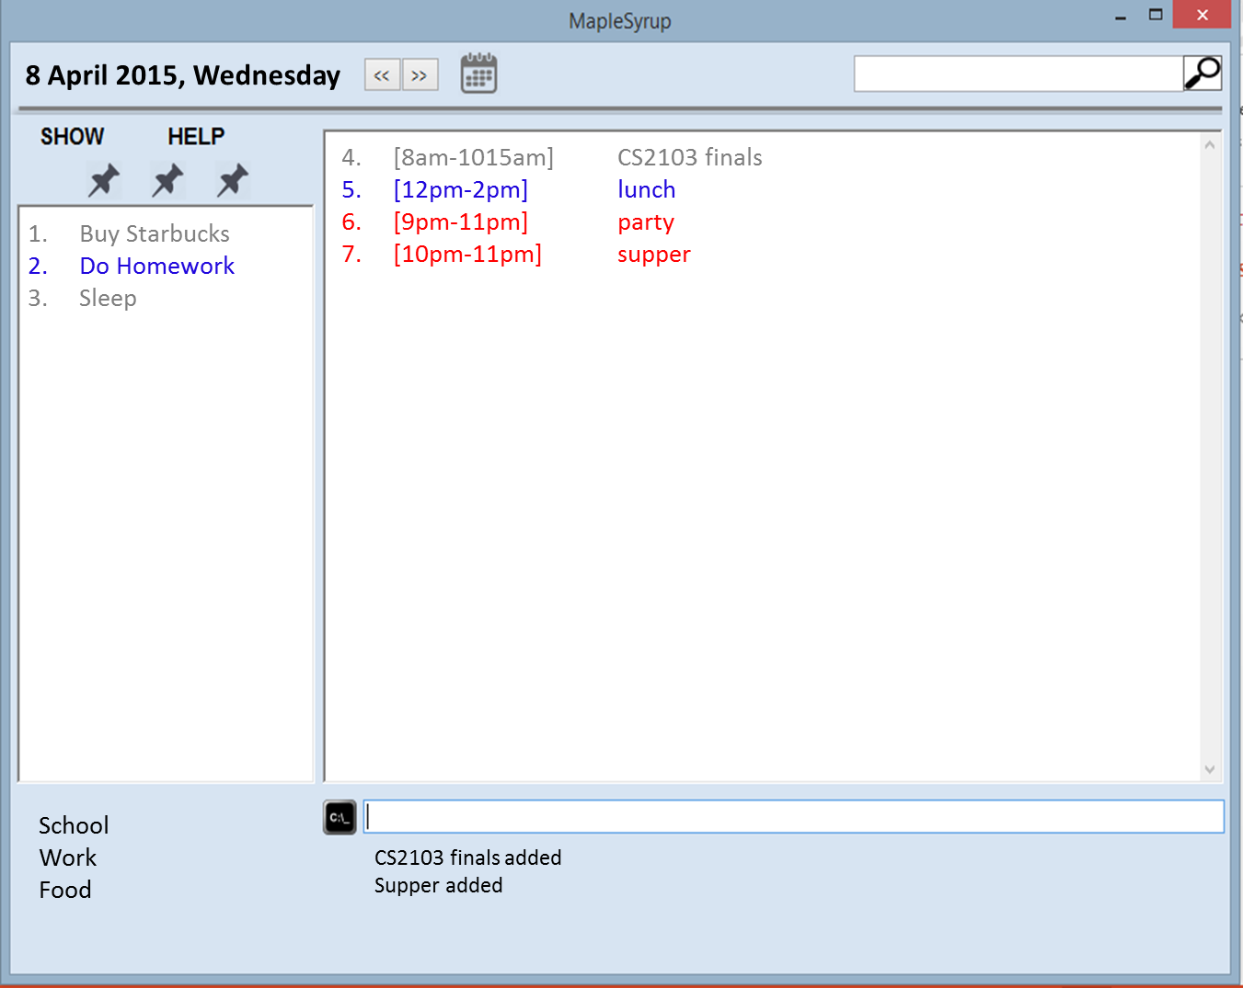

SEARCHING FOR AN EVENT
- Use the search bar at the top right of the window to search for the event. You can search by event name, date, description or tags.
- The top left box will show the label of what is being displayed on the main display which you have just searched.
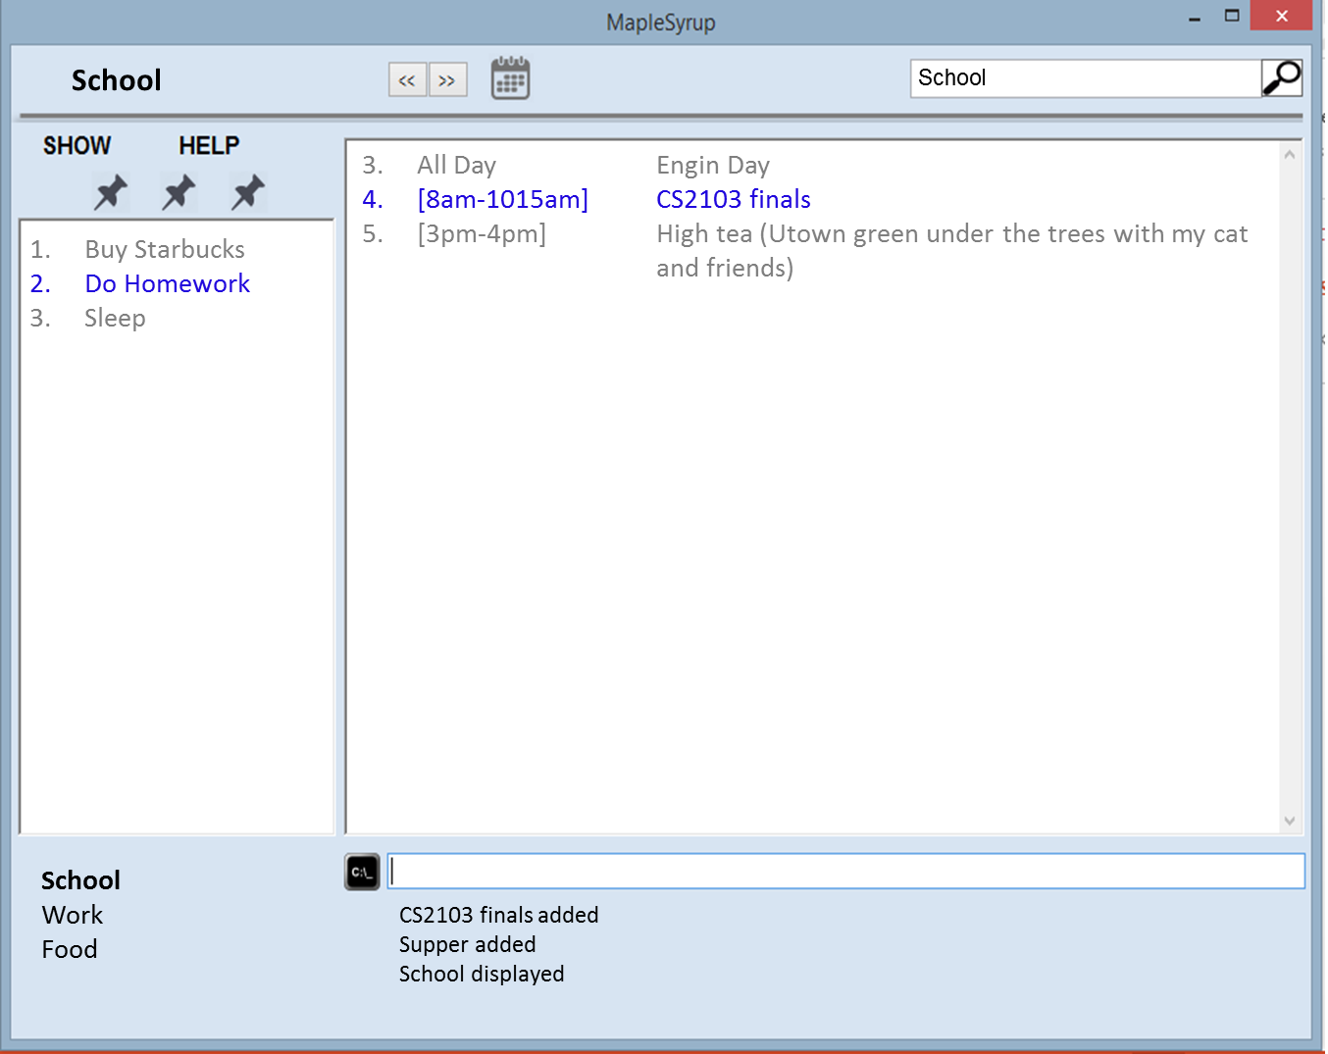

EDITING AN EVENT

- Type edit and suggestion Box will appear to show you the correct format of input.
- There are a total of n number of ways to edit an event: (refer to joshus’s docs)

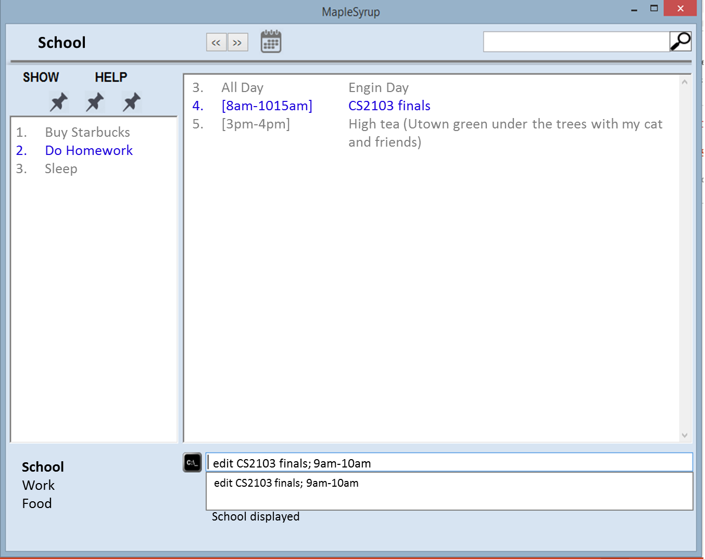

- Feedback box will display an acknowledgement “[Name of event] edited.”
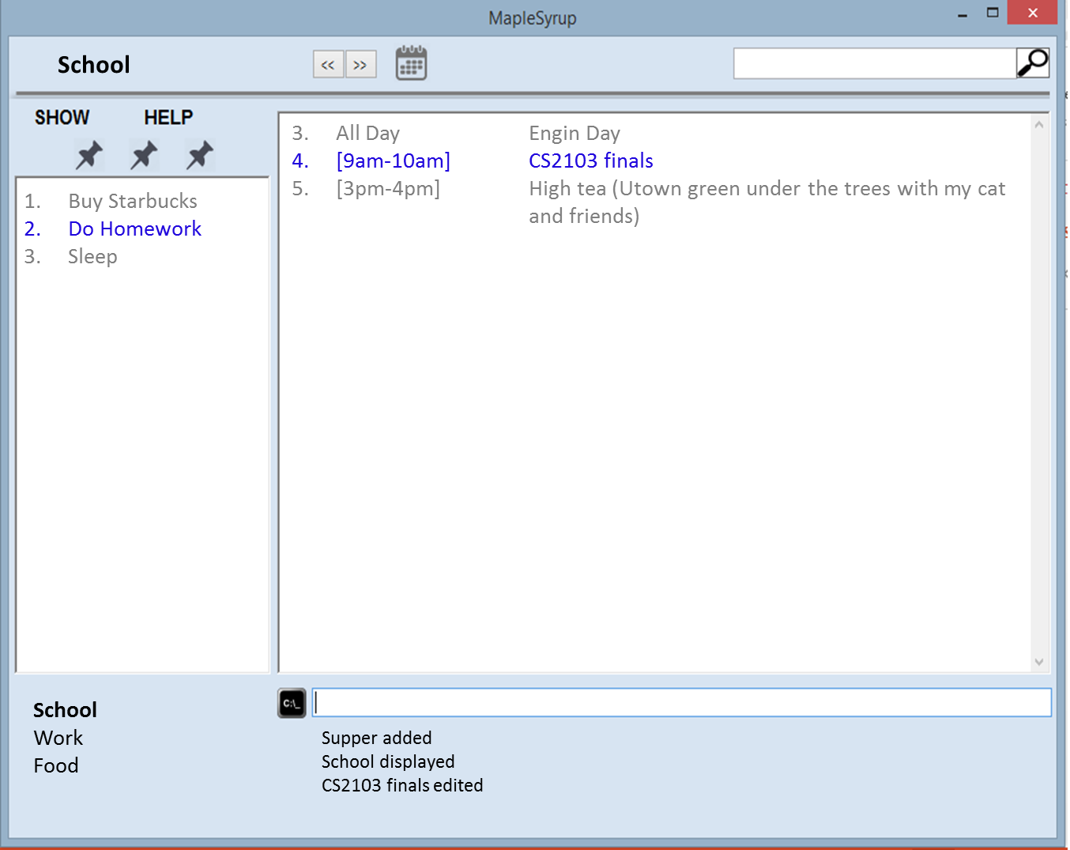
DELETING AN EVENT
- Type ‘delete’ and suggestion Box will appear to show you the correct format of input.
- Type in command box “delete [event index]” (e.g. delete 2).
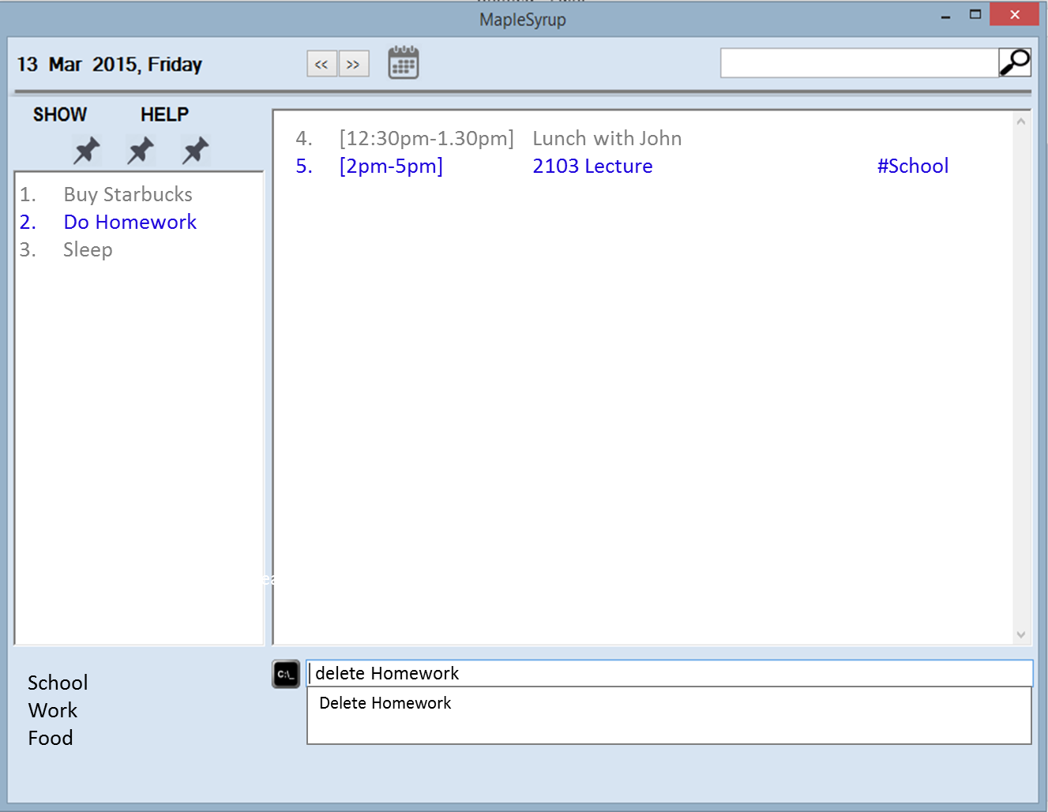

- Feedback box will display an acknowledgement “Event deleted.”
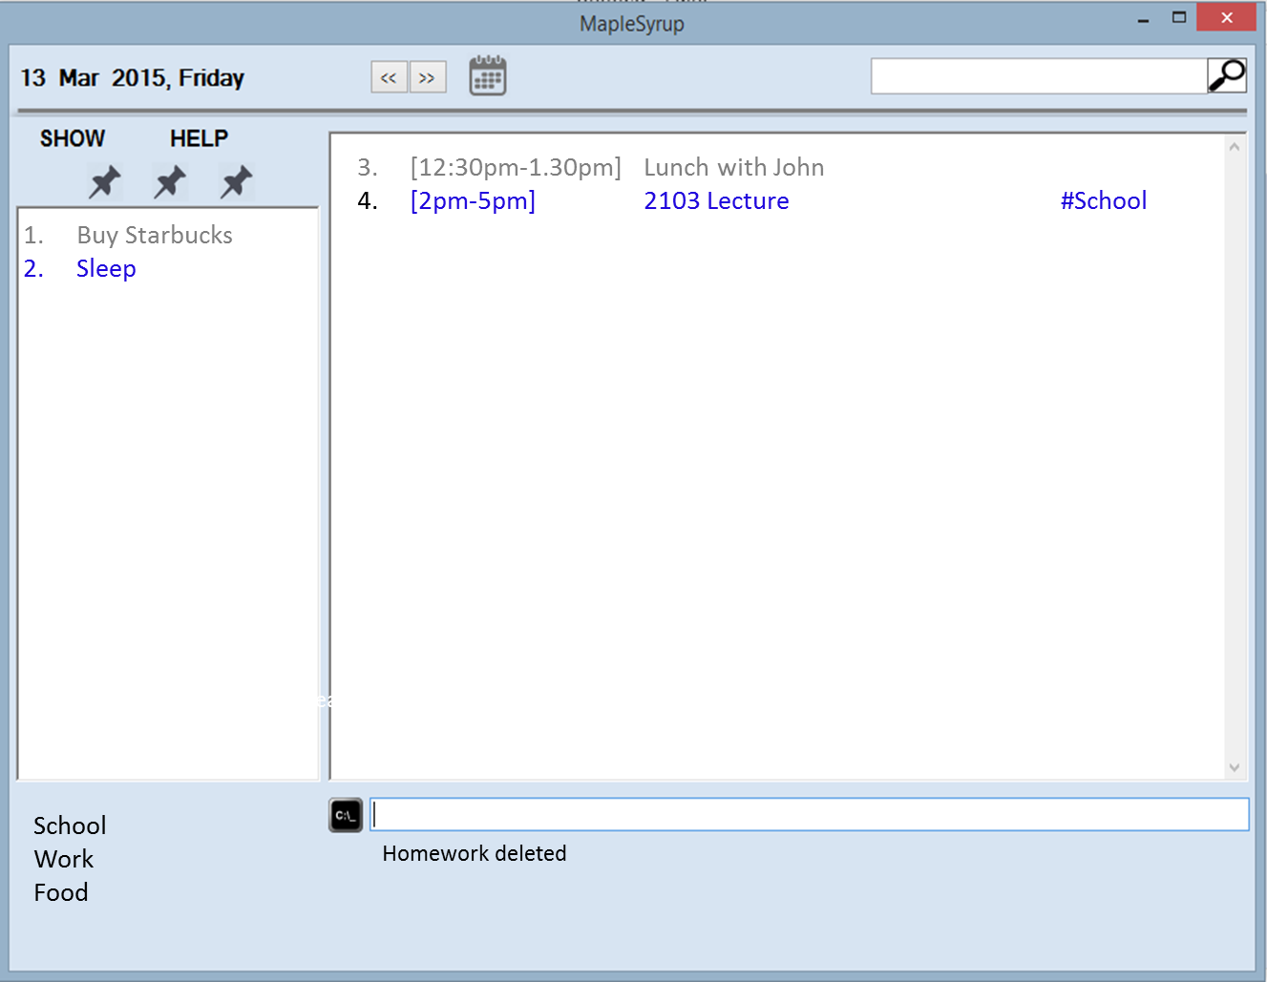

DISPLAYING EVENTS (BY SYSTEM DEFAULT CATEGORIES)- MONTH, WEEK, TODAY

Simple move your mouse over to “SHOW” and press on the format you would like to display.

Alternatively, one can type “show day”

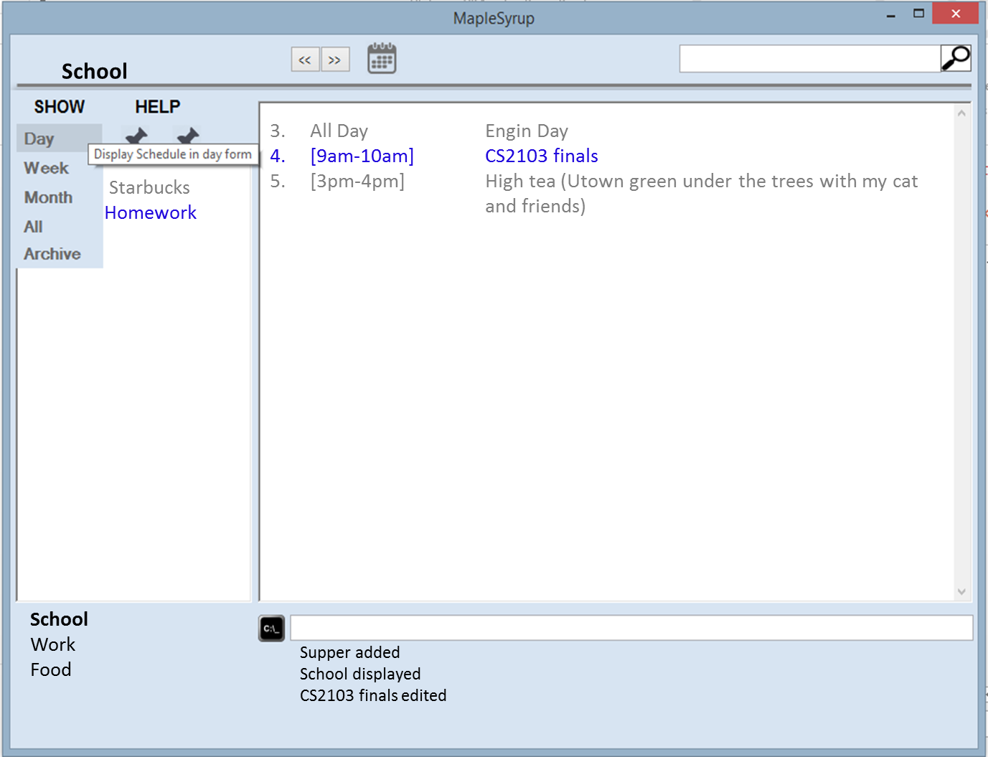

UNDO THE LAST ACTION
Simple move your mouse over to “HELP” and press ‘Undo’
Alternatively, you can also type undo on the command bar.
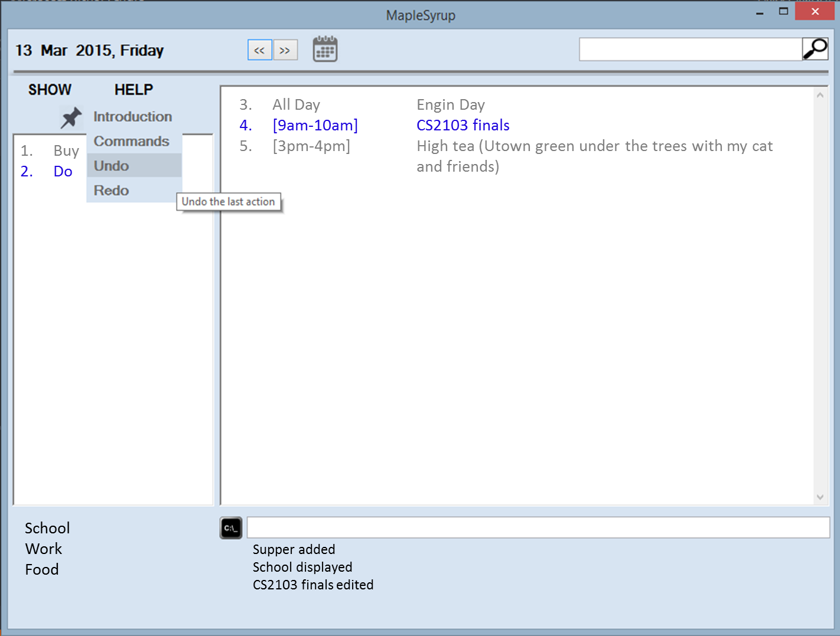
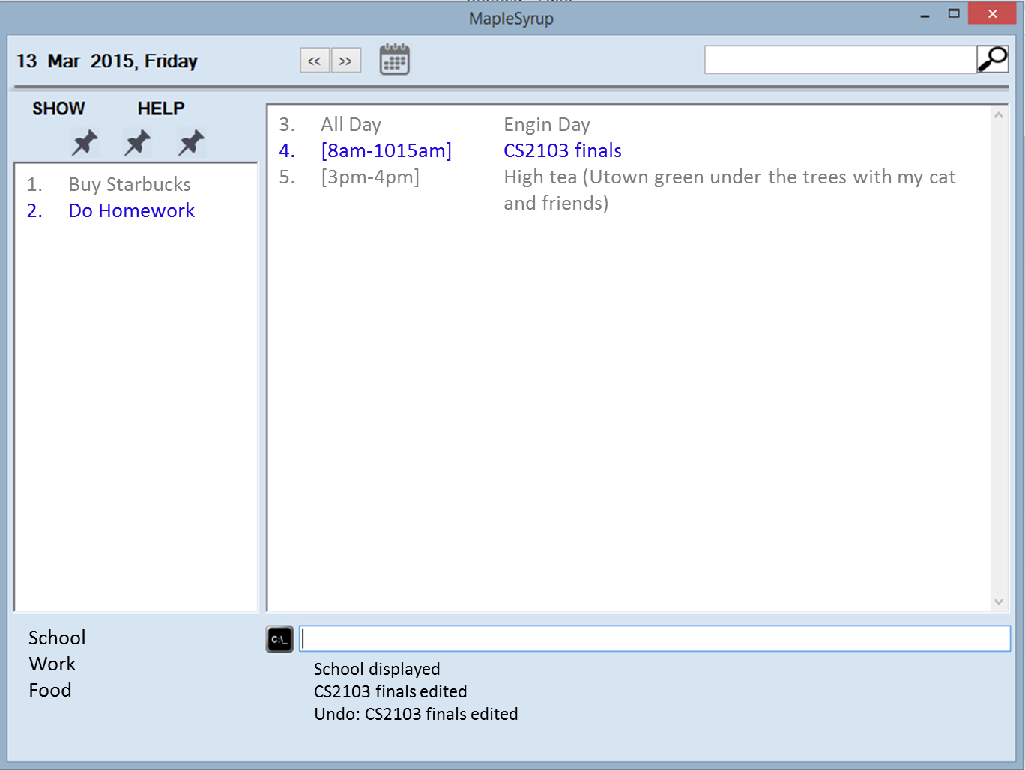

REDO THE LAST UNDO-ED ACTION
Simple move your mouse over to “HELP” and press ‘Redo’

Alternatively, you can also type redo on the command bar.

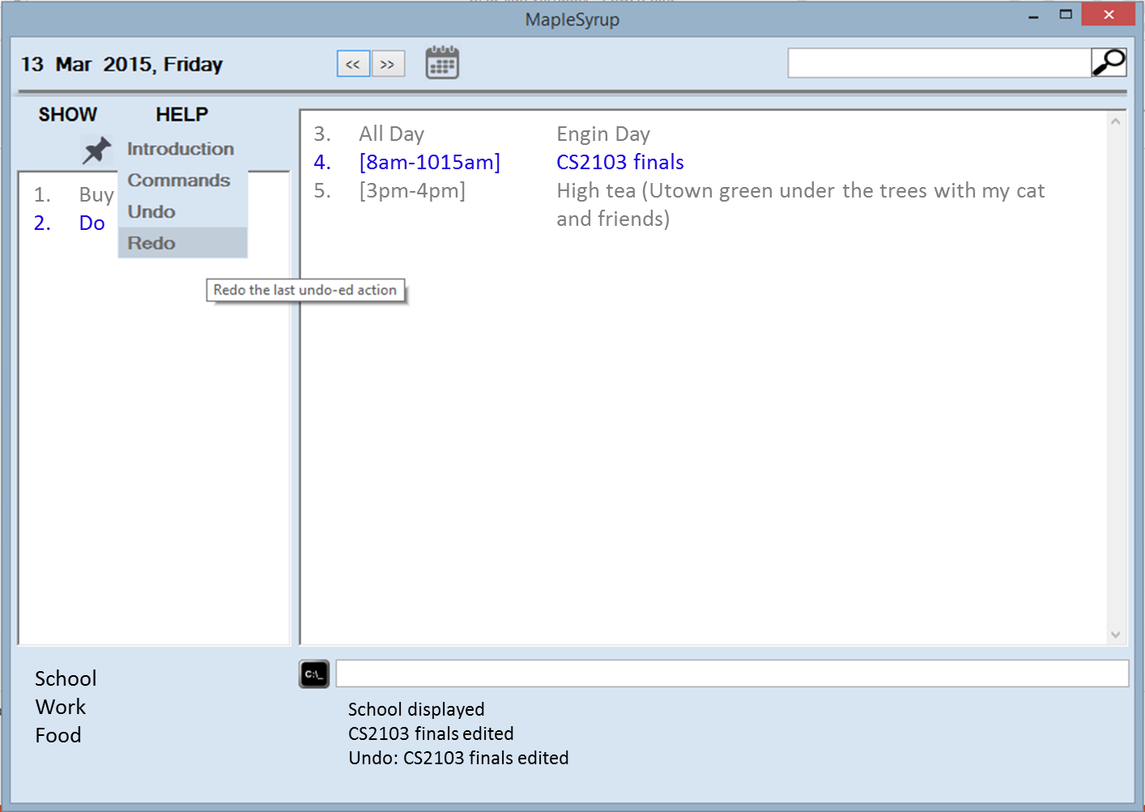
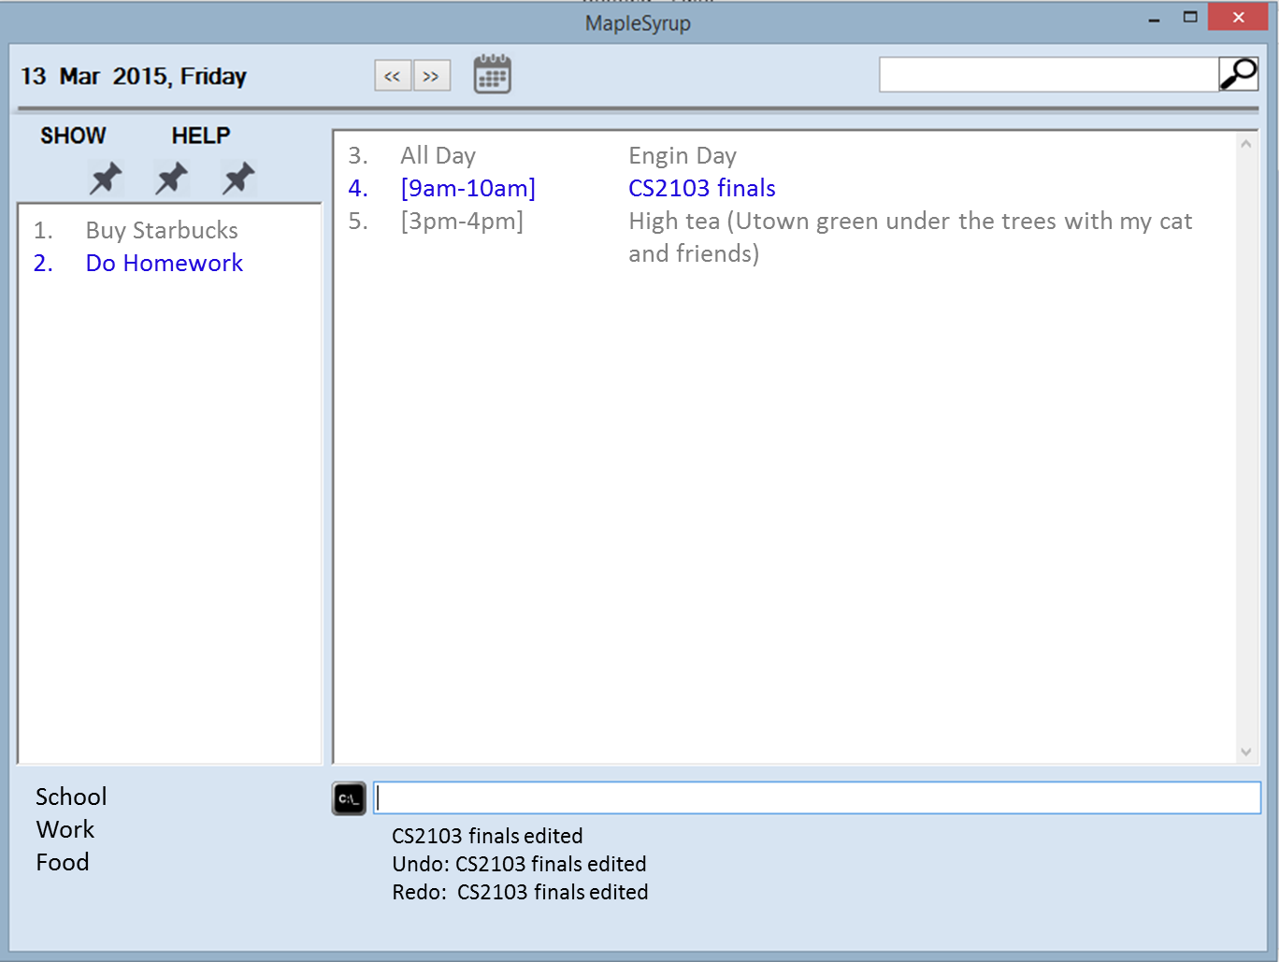

Appendix A: User stories. As a user, …

[Likely]
ID | I can … (i.e. Functionality) | so that I … (i.e. Value)
addFloating | add a task by specifying a task description only | can record tasks that I want to do some day
addLocation | Add location to an event | Will know where I need to be for that event
setRecurring | Set events to be recurring every day/week/month | Do not have to replicate similar events that occur every day/week/month
anyFormat | Enter new task in any format | Do not have to follow strictly to a certain format
setCategories | Organize my events/tasks by categories through tagging | Can search for any event/task easily
addAllDay | Add all day events | Do not have to specify time period spanning the whole day
setImportance | Rank my task by importance | Can sort tasks by importance and perform more important task first
viewAll | View all my task/events in an entire calendar | Can see how busy the week/month is going to be
setAbbreviations | Type in commands in the form of abbreviations | Save time by reducing amount of typing
setKeyboardCtrl | Open/close the software with keyboard commands | Have a quicker and simpler way of opening and closing the software
viewFreeSlots | View all free slots available | Better
setAutoSave | Save my inputs after every command | No loss of information if software accidentally closes
viewCompleted | View all completed tasks | Have a sense of accomplishment
reportClashing | Notified if there is any clashing events/tasks | Reschedule events/tasks to not have any clash
allowEdit | Edit my task information | Change any information at any time

[Unlikely]
ID | I can … (i.e. Functionality) | so that I … (i.e. Value)
addAlarm | Alarm/reminder when event is coming up | Will not miss important tasks
autoReschedule | Let the software auto reschedule my task if I fail to complete it during the set time | Do not need to set a new deadline again
setBufferTime | Set buffer time between events at different locations | Do not have a situation where I do not have time to travel from one event to the other
setAutoStart | Have the software auto start up when I turn on my computer | Can use the software immediately and be reminded of today’s event right away

Appendix B: Product survey

Product: Google Calendar Documented by: Ter Yong Kang
Strengths:
1. Event colour - allow user to classify events based on colour. This enhance the user experience.
2. Same event can be repeated more than 1 time.
3. Find time function - helps user to find a free time for the event to be added
4. Search function - allows user to search for events according to its details (name etc. etc.)
5. Display density allows user to choose the style of displaying calendar - enhances user experience
6. Displays only the important details of the event (Name & Time) on the summary page. Upon clicking the event, the full details of the event are being displayed. This provides a quick overview for the user without information overloading he/she.
7. A "help" section to provide a quick guide to new users on how to use the program
Weaknesses:
1. Unable to help user prioritise which event is most important given they overlaps
2. Unable to prioritise to user what event/activity to be complicated first
3. Does not allow user to add "floating tasks" without entering date and time
4. Unable to categorise events of the same type (e.g. work, family) together (except through colour)
5. Only able to display in Day Week Month 4Day. Should have more display options such as "display event according to priority" or "events of same type" etc.
Product: Macbook Calendar Documented by: George Lam Changwei
Strengths:
1. Able to add new events easily with detailed information such as location, day and time
2. Able to set alarms and reminder for to do events
3. Able to add invitees, notes, URL, attachments
4. Able to tag an item to sort by different categories.
5. Can sync to Iphone
Weaknesses:
1. Only on mac platform
2. Unable to recognise shortforms for users that prefers to type fast
Product: Wunderlist Documented by: Che Jian Yong Joshua
Strengths:
1. Able to set due date, and has options for recurring events daily, weekly, monthly, yearly, and even custom (every 2 days, or every 5 days)
2. Able to add additional details to the event
3. Able to star events to label as high priority.
4. Able to search for events based on event title as well as additional info typed on the event
5. Has sorting availability by due dates, and priority.
6. Has automatic grouping of events, by today and week.
7. Allows attaching of file to the event, such as emails or documents that contain additional information on the current event can be linked to
8. Has shortcuts available for quick addition, starring, completing, selecting
9. Keeps records of completed tasks for reference in the future if need be
Weaknesses:
1. Does not allow copying and pasting of events. Not able to set multiple due dates that does not follow a standard recurring structure.
2. Does not allow previewing of all the events in the form of a calendar for easier viewing. (Such as seeing how busy a certain week is)
3. Front page of website does not show all the events. Unable to set Today tab as the first tab viewed.
4. Events for the week cannot be sorted, fixed by due dates.
Product: Sony Calendar Documented by: Ong Wei Jee
Strengths:
1. Good GUI
2. Can view in day/week/month
3. Option to input location and detailed event description
4. Can specific exact time for events
5. Can set repetition for events
Weaknesses:
1. Setting time by scrolling through numbers is not efficient
2. Reminders only occur 10 minutes before the event
3. Must navigate to respective dates to view events, and it is not always obvious in the GUI

MapleSyrup Developer Guide

Table of Contents
Overall Architecture ................................................................................................................................ 1
GUI .......................................................................................................................................................... 2
Logic ........................................................................................................................................................ 3
Overview ............................................................................................................................................. 3
LogicExecutor ...................................................................................................................................... 3
LogicParser .......................................................................................................................................... 4
LogicData ............................................................................................................................................. 5
Command ............................................................................................................................................ 6
Command Execution Process .............................................................................................................. 7
Storage .................................................................................................................................................... 9
Task & State .......................................................................................................................................... 11
Task ................................................................................................................................................... 11
State .................................................................................................................................................. 12
Testing ................................................................................................................................................... 13

If no end time is stipulated it will automatically be set to 1 hour from the start time. If no date is stipulated it will automatically be set to the current date.

